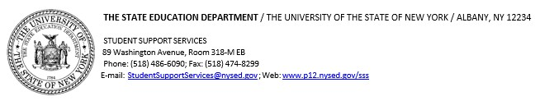

Date

Dear School Administrator,

The New York State Education Department (NYSED) and the Centers for Disease Control and Prevention (CDC) maintain a partnership to foster coordinated school health policies and programs for youth.

NYSED has contracted with the NYS Center for School Health (NYSCSH) to conduct the 2023 CDC Youth Risk Behavior Survey (YRBS).

Your school was randomly selected by the Centers of Disease Control (CDC) to participate in the Youth Risk Behavior Survey (YRBS), which consists of a written in-class student survey of students in grades 9 through 12 on priority health risk behaviors. The information generated from the 2023 YRBS is essential for measuring the effectiveness of prevention and education programs, ensuring accountability, and providing an index against which States may compare their own local YRBS results.

The behaviors the YRBS measures contributes to the leading causes of mortality and morbidity during both youth and adulthood. The information gathered helps determine the health status of youth throughout the country and assists educators in planning and implementation of effective coordinated school health programs including prevention of HIV infection and AIDS. Another, major priority is to help students develop the mindsets and behaviors that contribute to cognitive, emotional and physical health. The YRBS data is an invaluable tool to help promote health behaviors and avoid risk behaviors.

NYSED understands that the rights and anonymity of all students are protected, and that data will not be reported by school, district, or state, but rather it will be presented as representative data of the nation and New York State as a whole. Therefore, we encourage and recommend that school districts and schools participate voluntarily in this important activity.

Thank you in advance for your time and attention to this important initiative and for participating in this opportunity to positively impact health education in New York State. For further questions, please contact Shelly Budinski, YRBS Coordinator. Shelly’s contact information is listed below:

Shelly Budinski, MSEd

Health Education Resource Specialist

New York State Center for School Health

[www.schoolhealthny.com](http://www.schoolhealthny.com) (585) 617-2383

Sincerely,

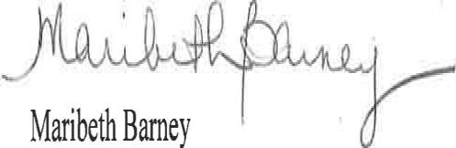

Maribeth Barney

Education Program Manager

Student Support Services

# cc: K. Hollowood, A.Lanoue